Organization Merger Update
One of the directives that our annual meeting last year asked us to investigate was a potential merger with other community organizations. Grow Garretson and the Garretson Industrial Development board have merged to form the Garretson Economic Development organization. Jessica Fueston is the appointed director of the organization, as part of her role working with the City of Garretson. Currently there is a five-person executive board.
Now that their organization has started taking shape, a next step is to merge with the Garretson Commercial Club, if that’s what you, the members of the Garretson Commercial Club, decide to do.
The structure of the Garretson Economic Development Organization could look like this:
Garretson Economic Development Organization
The goal of the Garretson Economic Development Organization is to create a single, stronger coalition to support and sustain the growth and development of Garretson. Along with a consolidated organization, the City of Garretson has appointed an employee to direct Economic Development and act as a main contact to engage in any opportunities that approach Garretson.
Structure: one legal 501 (C) 3 entity run by an executive board overseeing two subcommittees.
Executive Board: will be led by 5 directors chosen from the Garretson area and from working on sub-committees. The Executive Board would be responsible for the creation, implementation, and oversite of the organization’s strategic planning. The board will ensure that the Organization’s mission and goals are constantly being pursued.
Economic Development Director: The Director, hired by the City of Garretson, will be responsible for planning, designing, and implementing development and chamber strategies with consent of the board.
Sub-Committees: The Economic Development Organization would have separate committees overseen by the Executive Board.

- Sub-Committees

- Chamber of Commerce
  - Focus on marketing, events, tourism, business relationships and engagement, and community engagement.
- Development
  - Focus on development throughout the community, business attraction, sustainable growth, and outside partnerships.
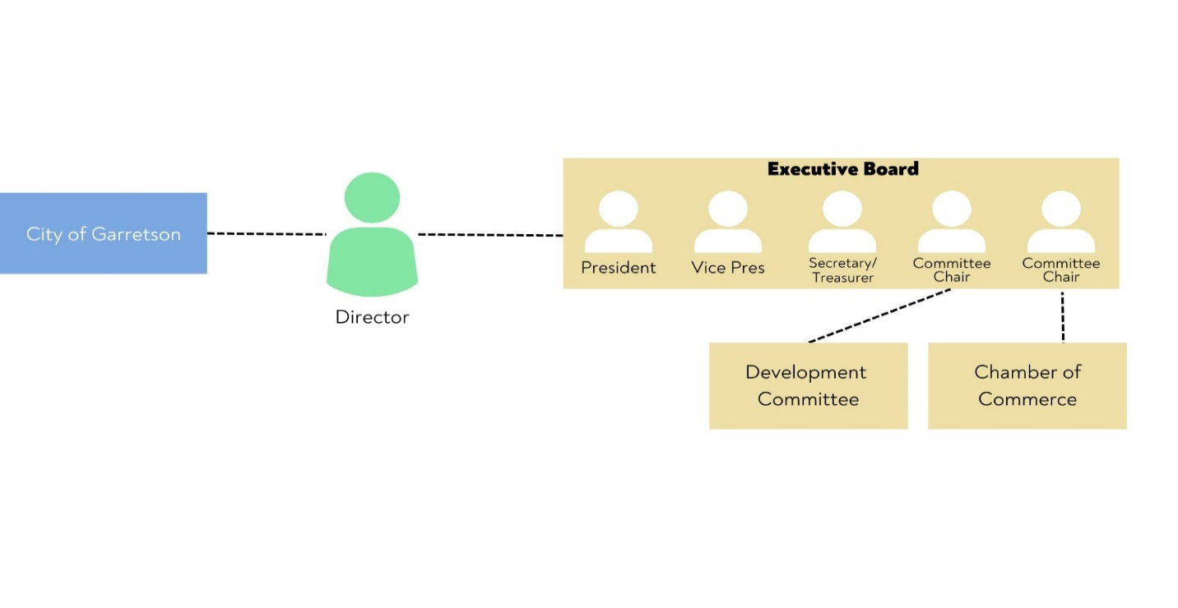
Jessica said that the plan currently for memberships would be a three-tiered system, each membership level increases in incentives. Whether or not we decide to merge, the board has already discussed raising membership dues since this has not been done since at least 2009.
We’d very much like as many Commercial Club members to attend this annual meeting as possible to discuss if this is in our best interest, the pros and cons, and potentially vote on the issue.
We would appreciate your attendance at the annual meeting on January 16, 2023 – 6:00pm at The Combine. This year we’re offering two complimentary meal tickets per member business to attend.

Some shared Pros and Cons, which can be viewed differently by everyone:
PROS: CONS:
More special events Limited representation with 5 vs 9 voting members
New faces, new ideas Time will be split 3 ways (less time for your business)
One membership cost vs two Costly to restart if consolidation fails (burn-out)
Possibly more member benefits Benefits possibly more expensive

